# Ali Zain K214653

Task #1:

Task #2:

Task #3:

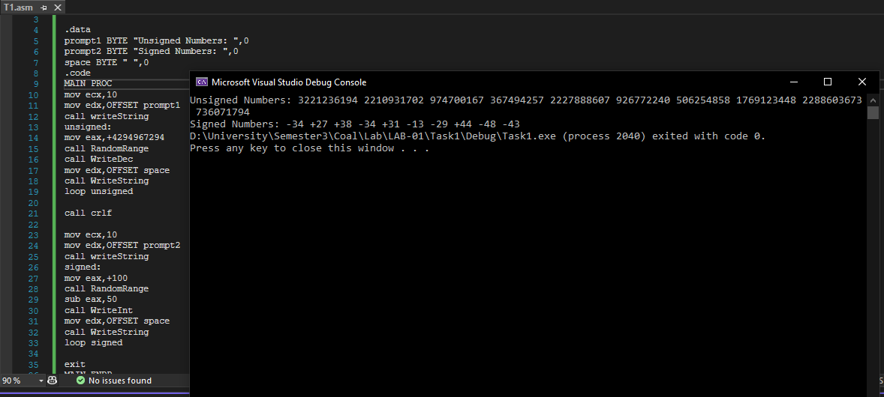

Task #4:

